COSC 3380
Name: ______________ PS ID # ___

Project 2: Implementation - SQL

(100 points)
(Due date found in the COSC 3380 Detailed Syllabus!)

1. 18 points
2. 40 points
3. 42 points

PLEASE ENTER YOUR GRADE IN THIS BOX & ALSO on the CHECK SHEET:
1. (20 points)

a. (15 points)
Using Project 1 Relations/Tables (including VIEWs) create them in the Oracle DBMS database. Create Project 2.sql that contains the Commented SQL commands that creates each table and view.

In Project 2.doc run one command at the time and take a screenshot of the commented command and its output and insert them in this document (for each table you create and each view you create).

b. (5 points)
Request the Table Relationships Diagram for the Database and “place” it in Project 2.doc (here).

This is just an example (please replace with yours, do not turn this in):
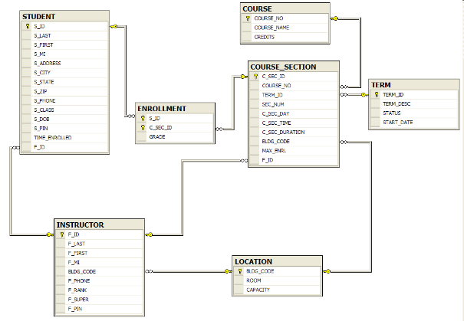

2. (30 points)

The Client has supplied the following data. Use SQL to insert these data in the Oracle DBMS database created in Project 1.

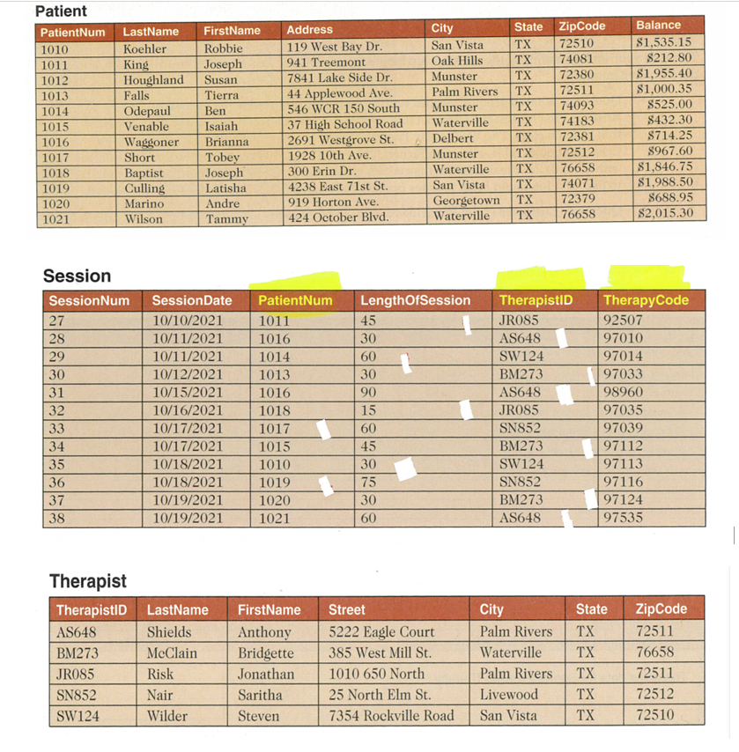
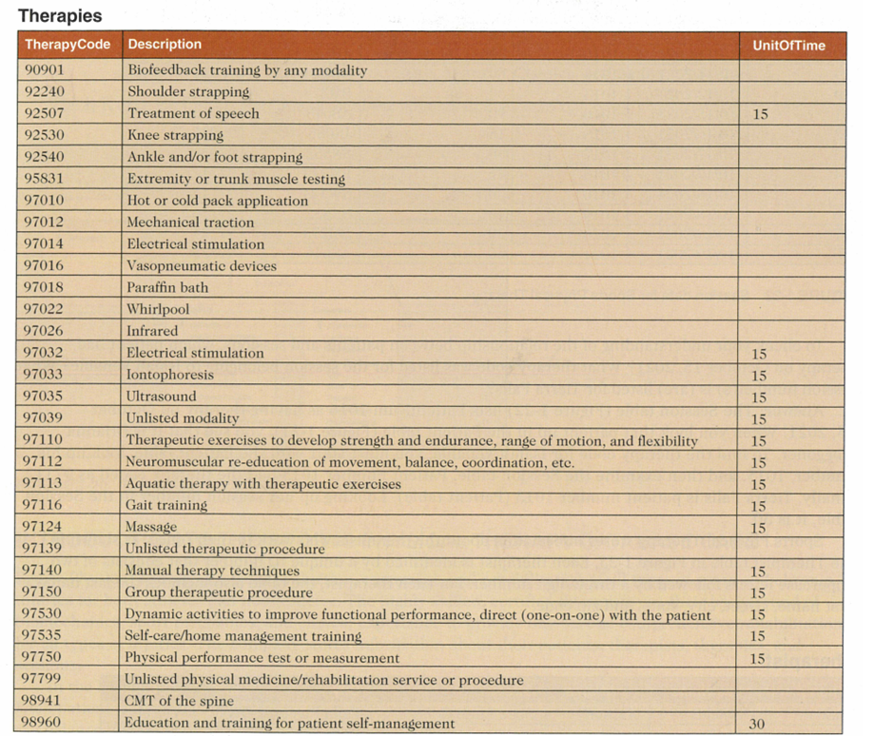

3. (50 points)

Create the SQL code for the following queries.
Please make sure you SQL COMMENT each query and place in Project 2.sql (after the each CREATE TABLEs and CREATE VIEWs).

Also take screenshots for each SQL COMMENT, SQL COMMAND, and SQL OUTPUT and place in Project 2.doc.

- (5 points)
List all the information in the Patient’s TABLE sorted by city.

(Screenshot for SQL COMMENT, SQL COMMAND, and SQL OUTPUT, to be placed in Project2.doc)

- (5 points)
List the last names of patients whose balance is greater than $1,000.
(Screenshot for SQL COMMENT, SQL COMMAND, and SQL OUTPUT, to be placed in Project2.doc)

- (5 points)
How long are the therapy sessions for the therapist whose last name is Shields? List the length of each session.

(Screenshot for SQL COMMENT, SQL COMMAND, and SQL OUTPUT…..)

- (5 points)
How many therapies are offered? Answer with one number only.
(Screenshot for SQL COMMENT, SQL COMMAND, and SQL OUTPUT…..)

- (5 points)
Displays the therapies and their unit of time for the therapies that include the word bath, hot, or electrical.

(Screenshot of the SQL COMMAND, SQL STATEMENT, and SQL …..)

- (5 points)
Show the session date and the last name and first name of the therapist. Show the list in chronological order.

(Screenshot of the SQL COMMAND, SQL STATEMENT, and SQL OUTPUT …..)

- (5 points)
Shows the patient number, patient last and first name, session date and session number sorted in chronological order last name, first name.

(Screenshot of the SQL COMMAND, SQL STATEMENT, and SQL OUTPUT …..)
- (5 points)
List the session date and therapist’s last name to display the upcoming schedule for the therapists.

(Screenshot of the SQL COMMAND, SQL STATEMENT, and SQL OUTPUT …..)

You need to turn in:
. The sql scripts with SQL COMMENTS for each query copied from this document and the expected output Project 2.sql.
Example:
# Q1 Which products have a standard price of less than $ 275?
# PRODUCTDESCRIPTION PRODUCTSTANDARDPRICE
# End Table 175
# Computer Desk 250
# Coffee Table 200

The screenshots of SQL COMMENTS, SQL Oracle COMMANDS and the SQL OUTPUT in Project 2.doc. Please be paper efficient!

Without Project 2.doc you will get ZERO!

Tips for the Projects:
- Prepare your SQL program using the Text editor such as Note Pad Project 2.sql.
- Copy and Paste your program from Project 2.sql to SQL*Plus command line.
- If the program works, save the program. Otherwise, fix the error for the program in Project 2.sql and try it again.
- Capture screenshots (CROP if needed) of the SQL COMMENTS, SQL COMMAND, and SQL OUTPUT and place them in Project 2.doc.
- Submit Project 2.sql that contains all your SQL COMMENTED SQL commands to BB.
- Submit Project 2.doc that contains all your screenshots to BB.
- Fill in the Cover Sheet and you are ready.

